

http://welcome.to/hausbamberg

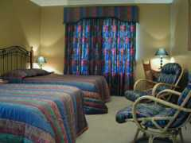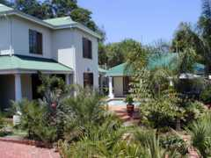

1. Location

Haus Bamberg is situated in the upmarket, tree-lined suburb of Waterkloof in Pretoria, South Africa.

- Within easy reach of Pretoria’s prime retail, business and entertainment districts.
- Easy access to highways and connections to Johannesburg International Airport.
- Conveniently close to the University of South Africa, the University of Pretoria, major government departments and international organisations.
- The Pretoria Country Golf Club is 750m from our doorstep.
- Brooklyn Mall and Menlyn Park, two world-class shopping and entertainment centres, are close by.

2. Accommodation

We offer superior accommodation at affordable rates in a secure tranquil setting with an established garden and swimming pool.

- Six spacious bedrooms, five with en-suite bathrooms and one with private bathroom.
- All rooms equipped with telephones, satellite TV and laptop facilities.
- Children of all ages are welcome.
- Reduced rates for longer periods of stay or frequent return visits.
- Payment can be made in any currency at local exchange rates, traveller’s cheques or a bank transfer.
- Standard security arrangement in place and undercover parking.

3. Services

Haus Bamberg offers a home away from home with emphasis on hospitality, personal service and individual attention.

- Transport to and from terminals as well as local sightseeing tours can be provided.
- Breakfast according to individual needs.
- Lunches and dinners can be served by prior arrangement.
- Laundry and dry-cleaning available.
- Game viewing safaris from three to ten days can be organized.
- English, Afrikaans and German spoken.

4. Bookings

Please contact Norman at Haus Bamberg to discuss your accommodation requirements and bookings.

367 Albert Street  Waterkloof  0181  Pretoria, South Africa | P.O. Box 95871  Waterkloof  0145  Pretoria, South Africa

Contact Numbers:  Tel: (+27) 012 460 3652  Fax: (+27) 012 346 2060  Cell: (+27) 083 468 3417 | Haus Bamberg Online:  Email: hausbamberg@mweb.co.za  Website: welcome.to/hausbamberg

